Jake Traut

CSCI 4446 Problem set 4

2. how to tell if stable/unstable – if system always returns to it after small disturbances (stable) or if the system moves away from the equilibrium after small disturbances (unstable)

1. Plot 1



This state space trajectory shows us that the initial condition [3, 0.1] is indeed close to the equilibrium point [3, 0]. Trying out a few different but close initial conditions showed me that this equilibrium point is **unstable**. For example the plot below, with IC = [3.14, 0.1], produces a very different output.

1. Plot 2 – this looks more like a perfect eclipse

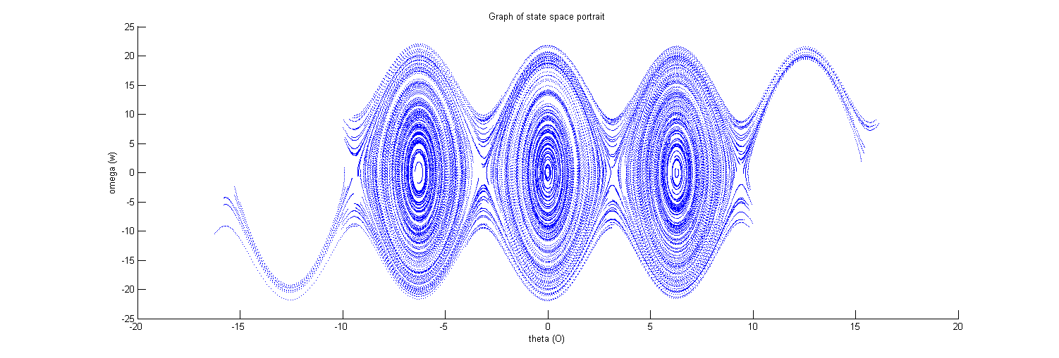3. State-space (phase) portrait

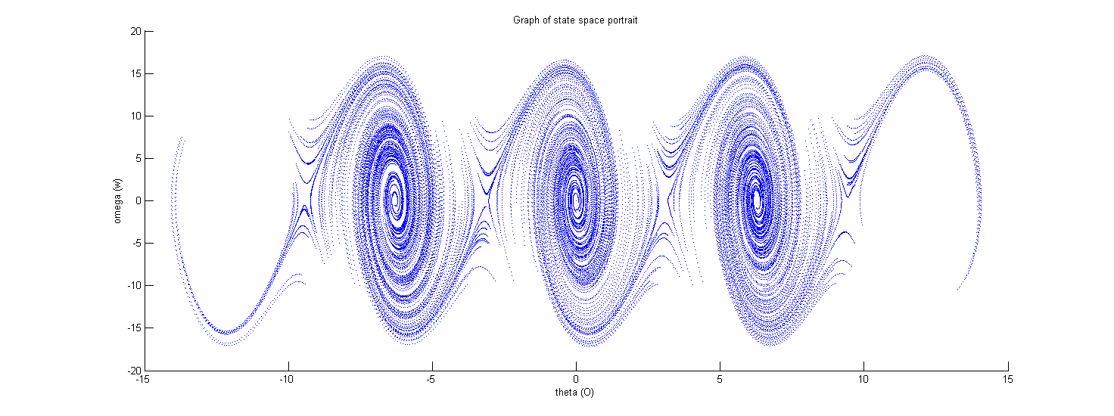4. beta = .25

4 cont. The elliptical features in the plot are being stretched vertically and skewed to the right, overall becoming less elliptical. The system is also becoming noticeably sparser, or less dense, along the exterior (the saddles) while remaining dense near the center points, as beta increases. The physical dynamics of this system must be becoming less stable as it is more prone to move out of the orbits. A lower beta value would have to produce the opposite effect, making the systems trajectories more elliptical and not skewed. I would also argue that there is a more consistent spread in the denseness of the system from center to exterior for lower beta values.

5. Plot with theta mod 2pi (beta = .25), appears zoomed in along the (0, 6.4) horizontal (theta) axis

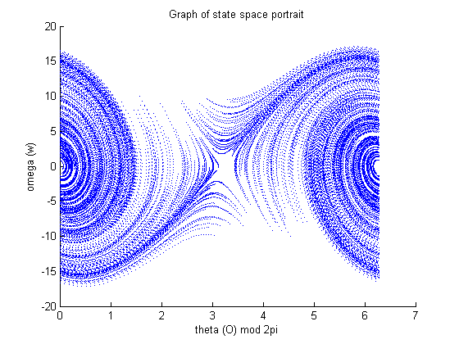

6. With drive on, the system can change drastically. When the amplitude A is still very small, i.e. .01s, and alpha ranges from about 0 to the natural frequency, things stay about the same. But, as A grows things begin to change and alpha begins to have a bigger impact on the centers and saddles. By A = .6, the left and right ellipses seen above have changed form and shape, the left one is more compact and dense while the right grows in size and is more spread out, and the lower alpha values make the centers more dense than the higher alpha values. But, when alpha >= 80% the natural frequency the trajectory gets messy (overlaps) near the centers of the ellipses.

Overall, these changes to alpha have less impact compared to the changes to the amplitude A in the way the system behaves. As A gets greater than .9 the dynamics become quite strange, with overlap and unclear trajectories that begin to take on a different overall phase portrait form.

Here is a plot with A = .6 and alpha = 80% natural frequency (.6*1.575)

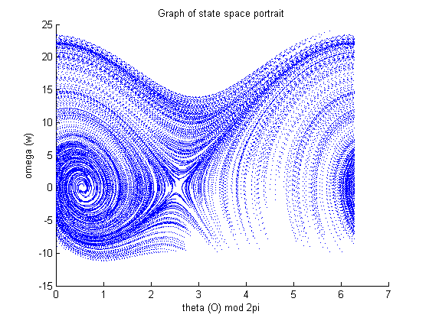

7. Decreasing the timestep h makes for a much denser plot, i.e. you only see complete curves. When you increase the timestep, like h = .01, you begin to notice all the individual dots that make up the curves or trajectories that you’re observing, now knowing the more popular spots along the way. At h = .05 the plot begins to look more like a mesh, you can still make out most the trajectory, but seen as if you were printing it and your printer was about to run out of ink. With a timestep of .1 you pretty much get the texture of spray paint, with a darker focused center that fades out the further it is from that center point. This actually makes for a good indicator of the most stable areas of the system that are explored the most, being the center fixed points. All these changes to the timestep still maintain the same overall shape, just with different textures.